

**Term Project**

**System Analysis**

**Section: 2**

**Semester:** Autumn 2022

**Submitted by:**

|  |  |
| --- | --- |
| **Tonmoy Baishnob** | **1830295** |
| **Fahad Kabir** | **1921785** |
| **Md. Rafiul khan** | **1820887** |

**Submitted to:**

Sabrina Alam

***Pre-Registration***

**Section 1:**

1. Introduction

2. History leading to project request

3. Identify Problem, opportunity

4. Project goal and objectives

**Section 2:**

5. Product Description

6. System Context diagram

7. Hardware detail (Include Rich Picture)

8. Key Technical Features of Software

**Section 3:**

9. Information Gathering methods (At least three methods)

10. Major functionalities offered by the system

11. Use Case Diagram

12. Normal Scenarios (At least 2)

13. Alternate Scenarios (At least 2)

14. Functional Requirements

15. Non-Functional Requirements (At least 5)

**Section 4:**

16. Entity Relationship Diagram

17. Logical Data Flow diagram

18. Physical Data Flow diagram

19. Activity diagrams

20. Sequence diagrams

21. Communication diagrams

22. Class diagrams

23. State-chart diagrams.

24. CRUD matrix

Section 5:

25. Structure English pseudo code for the system

26. Prototype the user interface

**Section 1:**

**1. Introduction:** Pre Registration is a system where students can register their desired course before the final registration. Through this process faculty and the head of the department will know how many students are interested in taking which course. By knowing this information they can prepare the section and the capacity of a section.

**2. History leading to project request:** During the registration process we all students have to face so many problems like capacity overflow of sections of the desired course, time clash with other courses and all.

Because of that the semester starts with a sad note like bad timing of classes. For that we have to wait the whole day to attend 2 classes in a day. Which is so time consuming as well. From that bad experience it comes to mind too. It would be really helpful for every student and the faculty as well. Because sometimes there are some sections of some courses which are not filled up and some are totally filled up with the students. So if pre registration happens then these kinds of problems can be solved.

**3. Identify Problem, Solution, opportunity:**

**Problem:** Time clashes with several courses.

**Solution:** By pre-registration it can be solved.

**Problem:** Capacity overflow of sections of a particular course.

**Solution:** After pre-registration faculties will get to know how much demanding is that course and how many sections should be allocated for that course and what should be the capacity.

**Problem:** After the registration most of the students have to wait for the add/drop session. Which will take at least 1 week and by then the first 2 classes get missed by the students.

**Solution:** By doing pre-registration there will be no need to do add/drop after the main registration.

**Problem:** Students want to take some major/optional courses but at that semester those courses are not offered during the registration period.

**Solution:** After pre registration, the registrar will be able to know which major/optional courses want to take the maximum number of students. And according to that data registrar will offer courses.

**Problem:** The sections and capacity of a particular course is high but the presence of enrolled students is very low.

**Solution:** After the pre registration the registrar will be able to know the exact number and after analyzing data will be able to allocate accurate sections and capacity.

**4. Project goal and objectives:**

**Goal:** This project aims to make course registration easier and simple.

The goal is to make sure every student gets their desired course stress freely.

**Objective:**

1. Set up a database
2. Select the Login and Registration system
3. Register the students.
4. Create Semester
5. Create Session
6. Create course
7. Create seat
8. Students login
9. Select semester
10. Select session
11. Select course
12. User Friendly.

**Section 2:**

**5. Product Description:**

1. **Product Summary:**

i. In this system, students will be able to do pre-registration before the final registration.

ii. It will include an option for students to select their preferable courses, sections and timing.

iii. All the data will be stored in the database and the registrar will be able to see all the data.

iv. By analyzing the data, the registrar will be able to allocate the courses, sections and the capacity of the section based on the students interest.

v. The system is very user friendly.

**b. Product Stakeholders**

**i. Registrar**

**ii. Student**

**iii. Developer**

**6. Context Level Flow Diagram:**

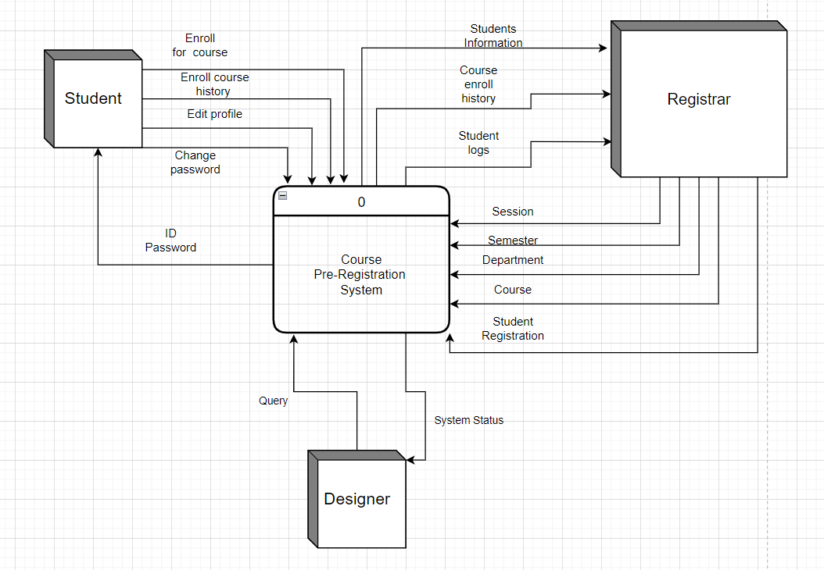

**7. Hardware & Software Details:**

**Components:**

|  |  |
| --- | --- |
| **Hardware** | **Software** |
|  |  |
| ~Laptop  ~Mobile Phone  ~Tab  ~Database server  ~App server  ~Website domain | ~This app will only work on the Android ~operating system because it is an Android application. On any other operating system, it will not work.  ~Android Studio Bumblebee  ~Flutter  ~XAMPP latest version. |
|  |  |

**Architecture:**

|  |  |
| --- | --- |
| **Hardware** | **Software** |
| ~A functioning internet connection with sufficient bandwidth.  ~ A laptop that has a Core i7 processor, 8GB of RAM, and a 512GB SSD.  ~At least 256 MB of free hard-drive space for mobile devices.  ~RAM must be at least 512 MB for mobile devices.  ~Adequate processor | 1. IOS (11.0 Tigris and later versions).  2. Android (versions 7.0 and up) |

**8. Software key technical features:**

1. Make course registration easier.
2. After pre-registration the registrar will be able to know about the students preferences of course.
3. By analyzing the pre registrations data, registrar will be able to

Allocate the exact course,section, and section.

1. Without any physical interaction with the students, the registrar will be able to know what students want through the system.
2. The system is very user friendly .
3. It needs constant internet connection.

**SECTION 3**

**9. Information Gathering Methods:**

Pre-Registration system is a web based system that will help the students to complete their final course registration efficiently and at the same time it helps the registrar to allocate the accurate number of sections and capacity. home. To set the requirements of our system, we collected information from the stakeholders. We followed three processes to gather information. They are Research, Questionnaire and Prototyping.

1. **Research:**

For this particular system, we had to go through a research process.

Through the research process we got to know about the students' preferences of course. This research help us to know several things like,

i. Which period classes students want to take like morning, noon or the afternoon.

ii. What kind of faculty they like most.

iii. How many students they think appropriate for a course in a single section.

iv. What type of course they like most.

v. How much pressure they feel during the registration time. Like the course they want to take, will it be available or not.

After the research, we were sure about how to design the prototype of our service.

**b. Questionnaire:** A very important part of our research was a questionnaire which was made for a better understanding of students' needs. Our questionnaire was designed to understand the pre-registration system of the students and how they want it to improve the system. The questionnaire is given below:

Answer the following questions about the Pre-Registration system—

1. **Name :____________________**
2. **ID: ___________\***
3. **Email:______________________\***
4. **Name of the department?\***

i. School of business and entrepreneurship.

ii. School of Engineering, Technology and science

iii.School of Environment and Life Sciences

iv. School of Environment and Life Sciences

v. School of Pharmacy and Public Health

1. **Semester?\***

i. 1-3

ii. 4-6

iii. 7-9

iv. 10-12

v. 13 or above

1. **Have ever faced any problem during your course registration?**

i. Yes

ii. No

1. **What kind of problems have you faced during registration? Select multiple answers.**

i. Capacity Overflow

ii. Time clash

iii. Server crash

iv. Lack of course that you want

1. **How would you rate your overall online registration experience?**

i. Excellent

ii. Average

iii. Poor

1. **Are you aware of the Pre_Registration system?\***

i. Yes

ii. No

1. **Will you appreciate the Pre-Registration System in your university?**

i. Yes

ii. No

1. **Do you think the Pre-Registration system is going to help you in final course registration to get your desired course?**

i. Yes

ii. No

We have done the survey and got a mixed of positive and negative responses in order of the students' experiences.

Almost everyone gave a positive response. They want it very eagerly in their university. As they face a lot of problems during registration, they think the Pre-Registration system is really needed for them.

Users with negative responses were happy with the traditional/current system and comfortable with it. Also didn’t want to adapt to a new system.

After the questionnaire was done, the vision of our system was more clear. We had to add and omit a few things that would make the system user friendly for the Students.

**c. Prototyping:**

For the next step of completing the Information gathering method, we have to make a prototype of our system. Prototyping is an experimental process where design teams implement ideas into tangible forms from paper to digital. In our case we make a system and launch it to my university students through my friend and friend of friends. We send our system link to the students as much as possible. And we collected their response about the pre-registration system . It helped us a lot to understand what students want, and how they want it. So almost everyone likes the whole system. But some of them advise us to improve the design of our system .

**10. Major functionalities offered by the system**

i. All the provided data by the user will be stored in the application database.

ii. Students with internet connection and an android phone or laptop can use this app.

iii. Can easily find their desired course in the system.

iv. Easily accessible features of our system will make the user experience better.

v. User Friendly system.

**11. Use Case Diagram:**

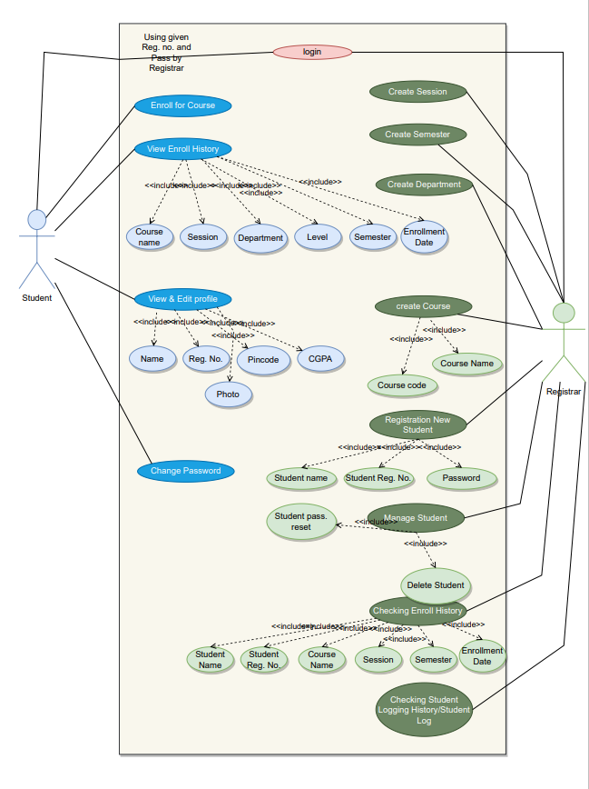

**12.Normal Scenario:**

**Scenario 1:**

|  |  |  |
| --- | --- | --- |
| **Use Case Name: Register student** | |  |
| **Actor(s): Registrar** | | |
| **Stakeholders: Registrar** | | |
| **Description: Registrar create an account for student** | | |
| **Triggering Event: Registrar create an account and inputs information.** | | |
| **Trigger type: External** | | |
| **Steps Performed:** | **Information Required for Steps:** | |
| **1. Login interface loads.** |  | |
| **2. Registrar login** | **The user/registrar wants to register a student.** | |
| **3. Registrar enters the following information: Email, name, ID No., password etc.** | **Personal information of the student like, name, ID no., password, email.** | |
| **4. Click the submit button.** | **All required information must be filled up.** | |
| **5. If all information is correct then the student will be registered to the system.** |  | |
| **6. A profile will be given to the student and a confirmation will be shown to the user interface.** | **Confirmation message will be shown.** | |
| **Pre-condition: User needs to have an idea about the features of the app.** | | |
| **Post-condition: Users have to carefully input all required information while registering.** | | |
| **Assumption: User wants to accommodate about course seats through the app.** | | |
|  |  |  |

**Scenario 2:**

|  |  |  |
| --- | --- | --- |
| **Use Case Name: Enroll for course** | |  |
| **Actor(s): Student.** | | |
| **Stakeholders: Student.** | | |
| **Description: Enroll for her/his desired courses** | | |
| **Triggering Event: User must select 3 course to enroll.** | | |
| **Trigger type: External** | | |
| **Steps Performed:** | **Information Required for Steps:** | |
| **1. User logs into the system** |  | |
| **2. Click to Enroll for course.** | **The user/registrar wants to register a student.** | |
| **3. A list of available courses will appear.** | **A list of available courses will appear with necessary information input like semester name, department name, session etc.** | |
| **4. Select courses and add additional information.** | **Course will be added with the additional information to the selection list.** | |
| **5. Submit the list.** | **All required information must be filled up.** | |
| **6. If all information is correct then enrolled courses will be submitted.** | **Confirmation message will be shown.** | |
| **7. Enroll for the courses will be done.** | **The enrolled courses with additional information will be added to the system. Confirmation message will be shown.** | |
| **Pre-condition: User must be registered to the app** | | |
| **Post-condition: User have successfully enrolled for courses** | | |
| **Assumption: User wants to enrolled for courses through the app.** | | |
|  |  |  |

**13. Alternative Scenario:**

**Scenario 1:**

|  |  |  |
| --- | --- | --- |
| **Use Case Name: Register student** | |  |
| **Actor(s): Registrar** | | |
| **Stakeholders: Registrar** | | |
| **Description: Registrar create an account for student** | | |
| **Triggering Event: Registrar create an account and inputs information.** | | |
| **Trigger type: External** | | |
| **Steps Performed:** | **Information Required for Steps:** | |
| **1. Login interface loads.** |  | |
| **2. Registrar login** | **The user/registrar wants to register a student.** | |
| **3. Registrar enters the following information: Email, name, ID No., password etc.** | **Personal information of the student like, name, ID no., password, email.** | |
| **4. Click the submit button.** | **All required information must be filled up.** | |
| **5. If any information is not correct then an error message will be shown that information is not valid and prompted to enter valid information.** | **Error message, invalid information** | |
| **6. The user will input correct information and continue with the registration.** | **Correct information.** | |
| **. A profile will be given to the student and a confirmation will be shown to the user interface.** | **Confirmation message will be shown.** | |
| **Pre-condition: User needs to have an idea about the features of the app.** | | |
| **Post-condition: Users have to carefully input all required information while registering.** | | |
| **Assumption: User wants to accommodate about course seats through the app.** | | |
|  |  |  |

**Scenario 2:**

|  |  |  |
| --- | --- | --- |
| **Use Case Name: Enroll for course** | |  |
| **Actor(s): Student.** | | |
| **Stakeholders: Student.** | | |
| **Description: Enroll for her/his desired courses** | | |
| **Triggering Event: User must select 3 course to enroll.** | | |
| **Trigger type: External** | | |
| **Steps Performed:** | **Information Required for Steps:** | |
| **1. User logs into the system** |  | |
| **2. Click to Enroll for course.** | **The user/registrar wants to register a student.** | |
| **3. A list of available courses will appear.** | **A list of available courses will appear with necessary information input like semester name, department name, session etc.** | |
| **4. Select courses and add additional information.** | **Course will be added with the additional information to the selection list.** | |
| **5. Submit the list.** | **All required information must be filled up.** | |
| **6. If any information is not correct then an error message will be shown that information is not valid and prompted to enter valid information.** | **Error message, invalid information** | |
| **7. The user will input correct information and continue with the registration.** | **Correct information.** | |
| **8. Enrolled courses will be submitted.** | **Confirmation message will be shown.** | |
| **9. Enroll for the courses will be done.** | **The enrolled courses with additional information will be added to the system. Confirmation message will be shown.** | |
| **Pre-condition: User must be registered to the app** | | |
| **Post-condition: User have successfully enrolled for courses** | | |
| **Assumption: User wants to enrolled for courses through the app.** | | |
|  |  |  |

**14. Functional Requirements:**

Functional requirements are product features or functions those developers must implement to enable users to accomplish their tasks. So, it's important to make them clear both for the development team and the stakeholders. The functional requirements of our system are:

1. Users will be able to access the system via multiple devices.
2. Registrar will sign up to the system and can register students with id and password .
3. Registrar can create a new semester.
4. Registrar can create a new session.
5. The Registrar can create a Department.
6. Registrar can create courses.
7. Registrar can create the seat limit of courses.
8. Registrar can manage the students.
9. Registrar can check the enrollment history.
10. Students can login to the system with the id password.
11. Students can edit their profile.
12. Students will get their unique pincode.
13. For every student there will be a unique pincode to identify the students.
14. By using the unique pincode student will be able to do the course pre-registration.
15. Students can select their semester.
16. Students can select their Department.
17. Students can select their session.
18. Students can select their course.
19. Students can change the password
20. Will encrypt all user data and host it in the cloud for data security.
21. All information will be stored in the app database.

**15. Non Functional Requirements:**

A non-functional requirement is one that defines criteria that can be used to evaluate a system's performance rather than specific actions. Functional requirements, on the other hand, define precise behavior or functions. Our system's non-functional requirements are as follows:

1. The user interface must be user friendly.

2. Students should be able to interact with one another.

3. To reduce the number of bugs, the software must be updated on a regular basis.

4. To process all the data, the hardware must be powerful.

5. It must protect users' privacy and provide security

6. The system must be designed in such a way that it can be readily maintained, updated, or upgraded in the future to add new features.

7. To ensure robustness and eliminate any security threats, the system must be checked and maintained on a regular basis.

**Section 4:**

**16. Entity Relationship Diagram**

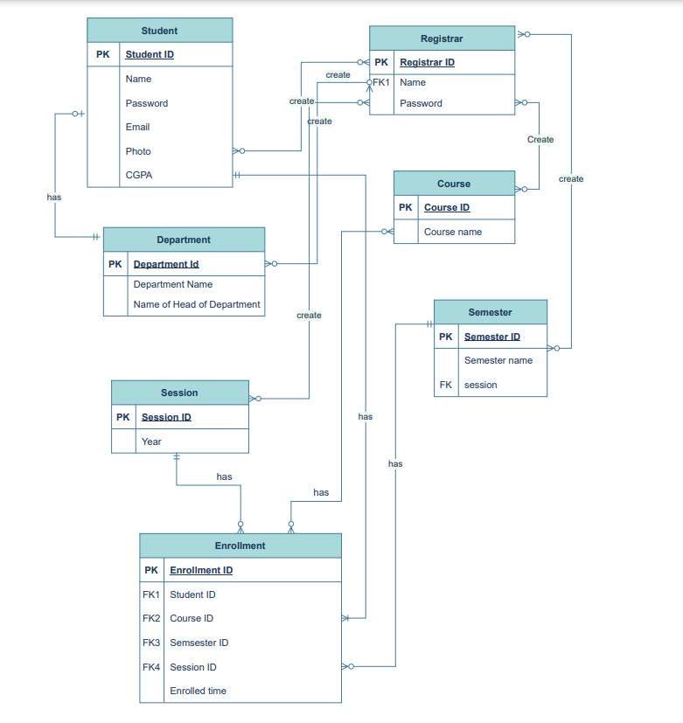

**Fig 4.1: E-R Diagram**

**17. Logical Data Flow diagram:**

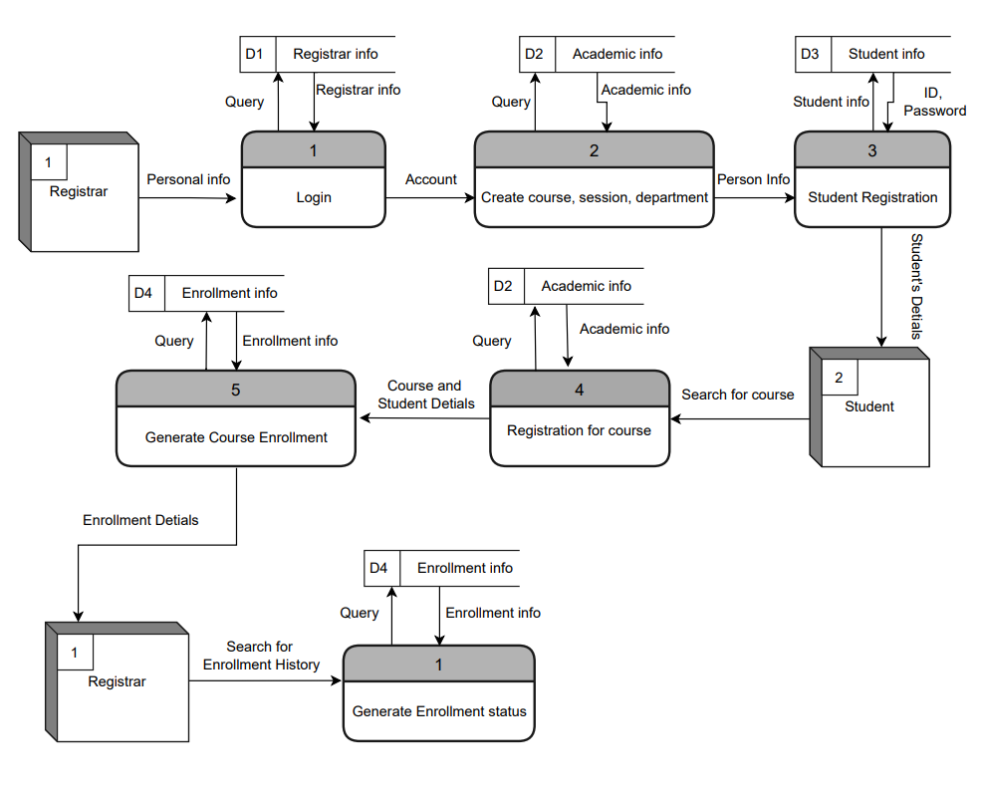

**Fig 4.2: Logical Data Flow Diagram**

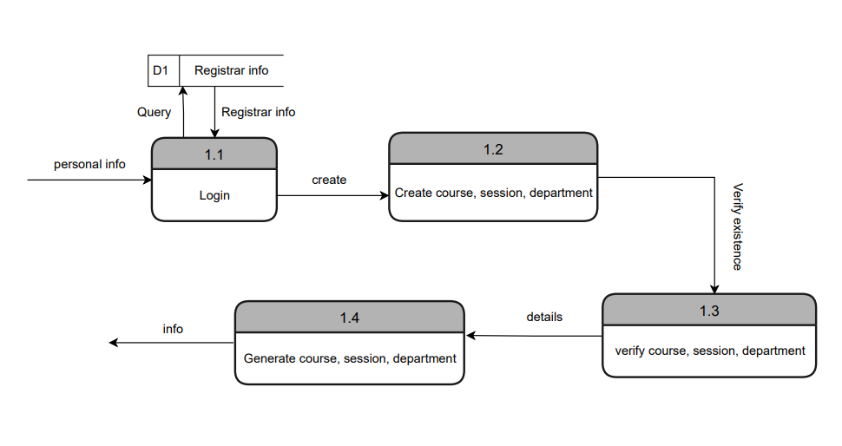

**Fig 4.2a: Data Flow Diagram for “Create course, session,department”**

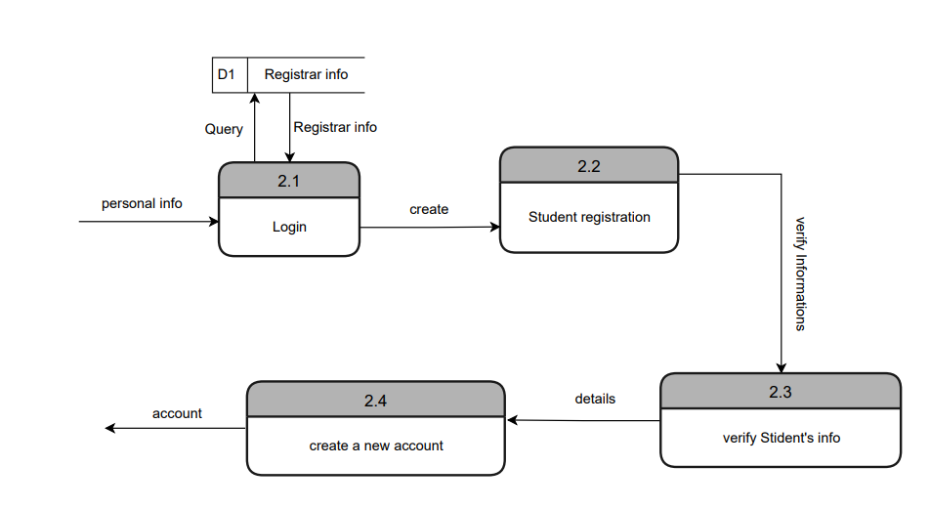

**Fig 4.2b: Logical Data Flow Diagram for “Student Registration”**

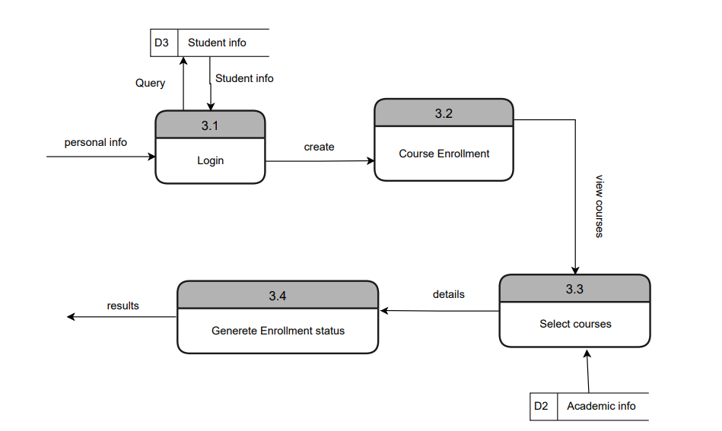

**Fig 4.2c: Logical Data Flow Diagram for “Course Enrollment”**

**18. Physical Data Flow diagram**

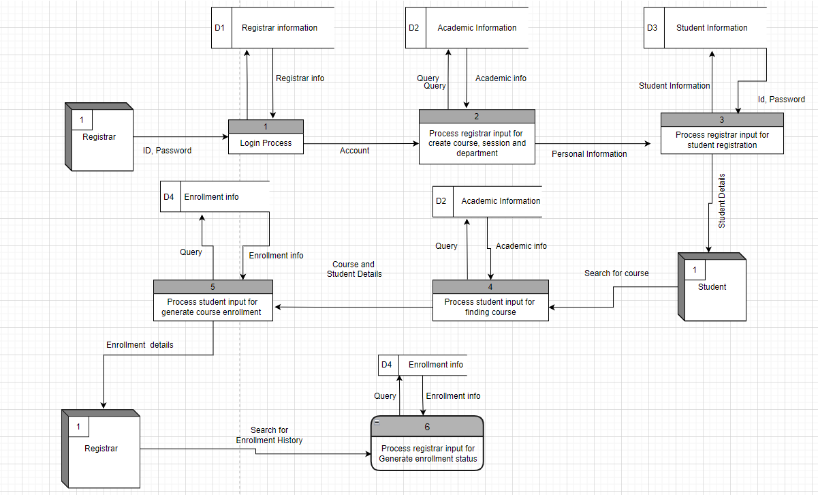

**Fig 4.3: Physical Data Flow Diagram**

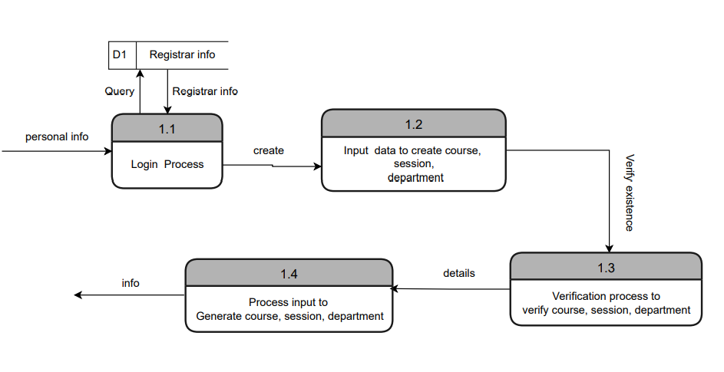

**Fig 4.3a: Physical Data Flow Diagram “Create course, session, department”**

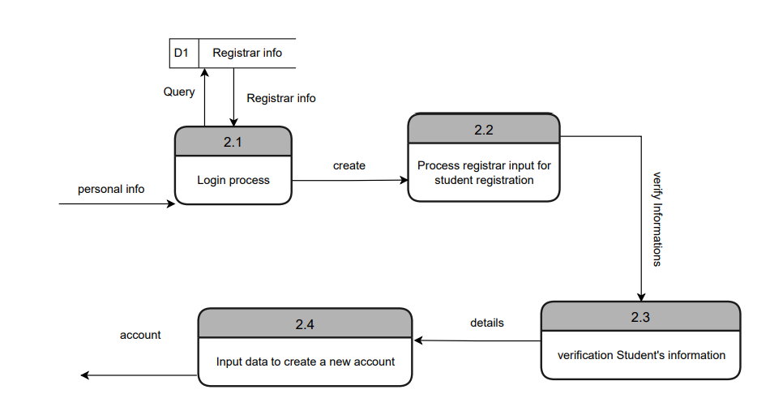

**Fig 4.3b: Physical Data Flow Diagram “Student Registration”**

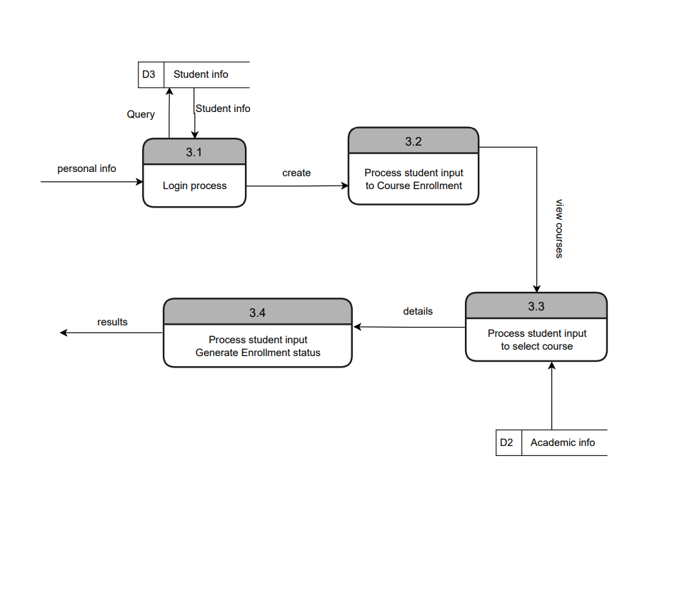

**Fig 4.3c: Physical Data Flow Diagram “Course Enrollment”**

**19. Activity Diagram**

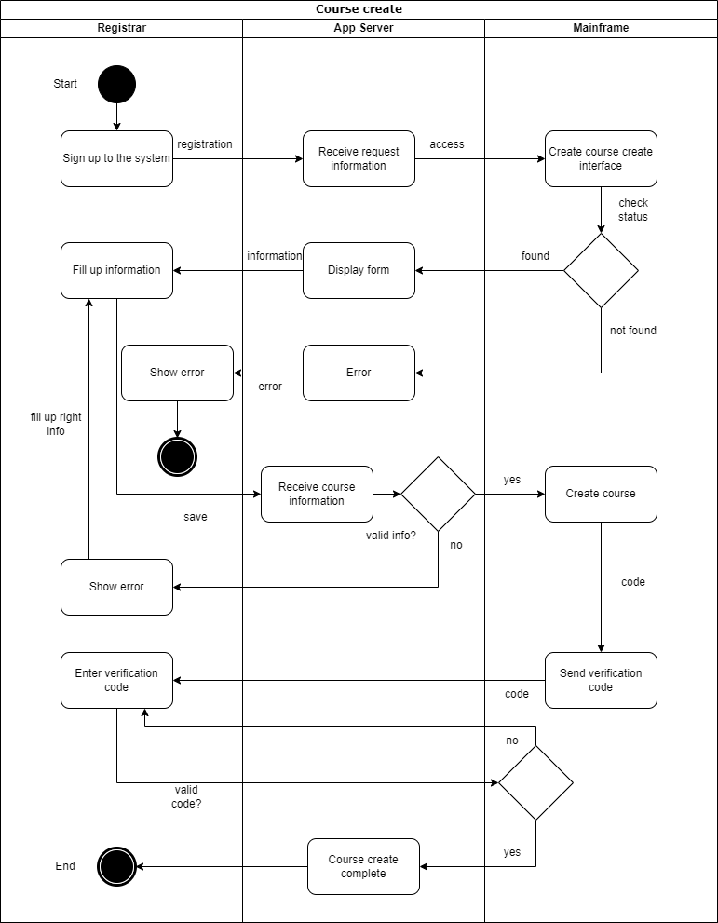

**Fig 4.4a: Activity Diagram for “Registrar course create”**

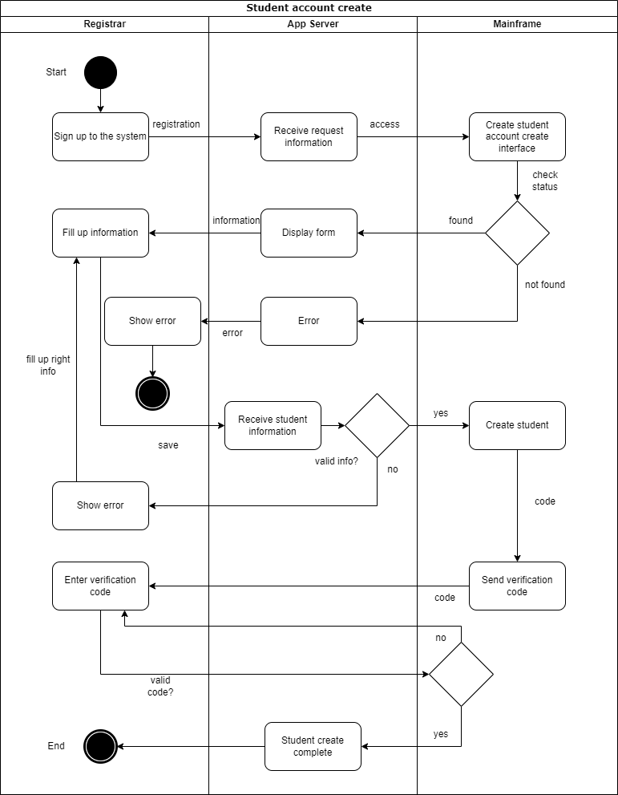

**Fig 4.4b: Activity Diagram for “Registrar create student account”**

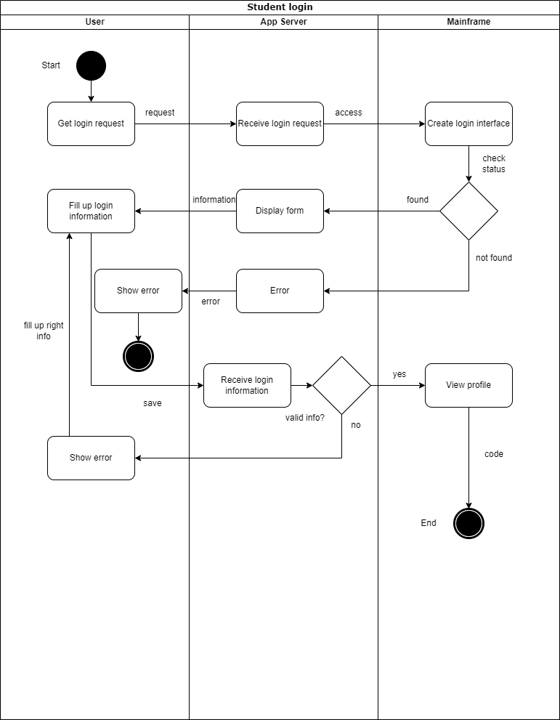

**Fig 4.4c: Activity Diagram for “Student login”**

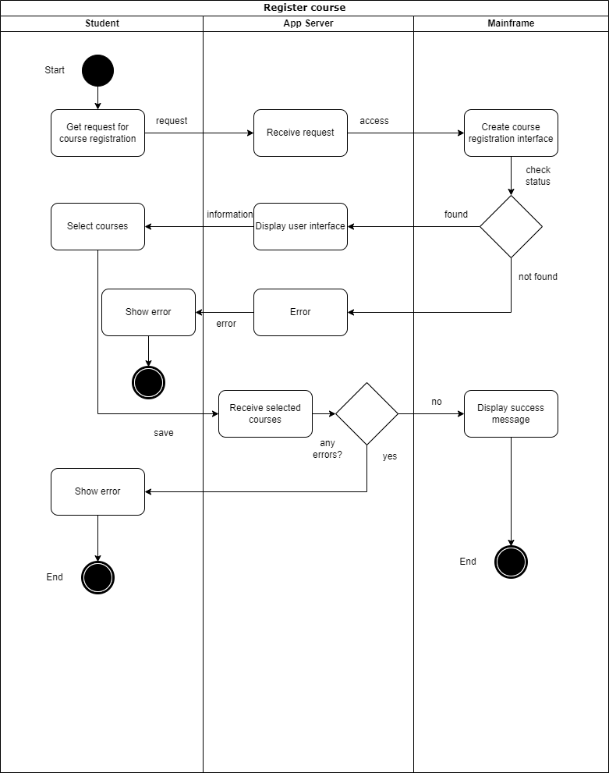

**Fig 4.4d: Activity Diagram for “Register course”**

**20. Sequence Diagram**

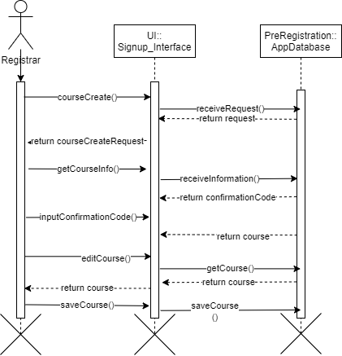

**Fig 4.5a: Sequence Diagram for “Registrar course create”**

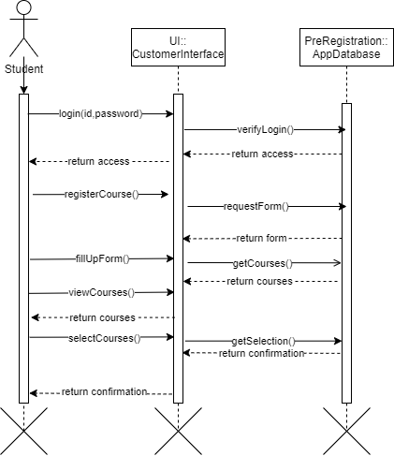

**Fig 4.5b: Sequence Diagram for “Register course”**

**21. Communication Diagram**

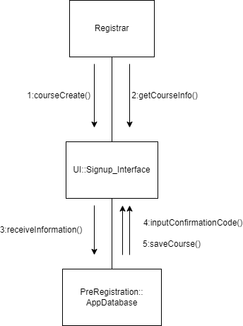

**Fig 4.6a: Communication Diagram for “Registrar course create”**

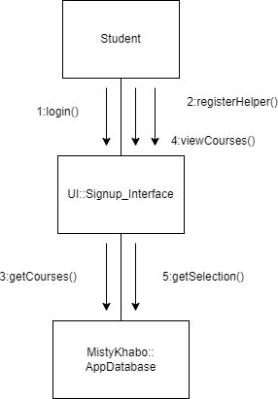

**Fig 4.6b: Communication Diagram for “Register course”**

**22. Class Diagram**

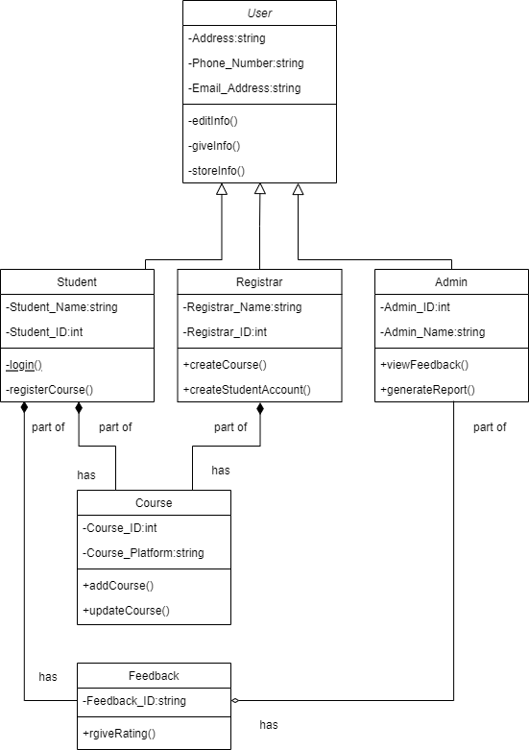

**Fig 4.7: Class Diagram for “Register course”**

**23. State-chart Diagram**

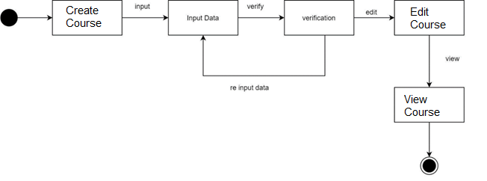

**Fig 4.8a: Statechart Diagram for “Registrar course create”**

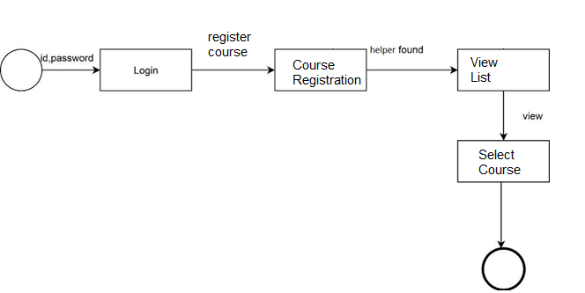

**Fig 4.8b: Statechart Diagram for “Register course”**

**24. CRUD Matrix**

|  |  |  |  |  |
| --- | --- | --- | --- | --- |
| **Activity** | **Registrar** | **Student** | **Admin** | **Feedback Report** |
| **Register** | **C** |  |  |  |
| **Login** | **R** | **R** |  |  |
| **Edit profile** | **U** | **U** | **R** |  |
| **Register Courses** | **R** | **U** | **U** |  |
| **Generate Report** |  |  | **RU** | **C** |
| **Give Feedback** |  | **C** |  | **U** |
| **Delete**  **Report** |  |  |  | **D** |

**Section 5:**

**25. Structure English pseudo code for the system:**

**Enroll for course**

Login to the System

IF login done successfully

DO While students is logged into the system

F not pressed in “Enroll for Course” button

THEN display Home page for students

ELSE

Search in database for Enroll for course

IF Enroll for course found in database

THEN show results of Enroll for course and it’s courses

IF pressed in “Enroll for course” button

THEN show results of Enroll for course and it’s all courses

ELSE show error

ENDIF

ELSE show error

ENDIF

ENDIF

ENDDO

ELSE

Show error

ENDIF

**Edit Profile**

DO While student is logged into the system

IF User has filled all required input fields

DO update old information with new input information in database

DISPLAY Updated student profile.

END IF

END DO

**Enroll History**

Login to the System

IF login done successfully

DO While students is logged into the system

F not pressed in “Enroll History” button

THEN display Home page for students

ELSE

Search in database for Enroll History

IF Enroll History found in database

THEN show results of Enroll History and it’s courses

IF pressed in “Enroll History ” button

THEN show results of Enroll History and it’s all courses

ELSE show error

ENDIF

ELSE show error

ENDIF

ENDIF

ENDDO

ELSE

Show error

ENDIF

**26. Prototype the user interface:**

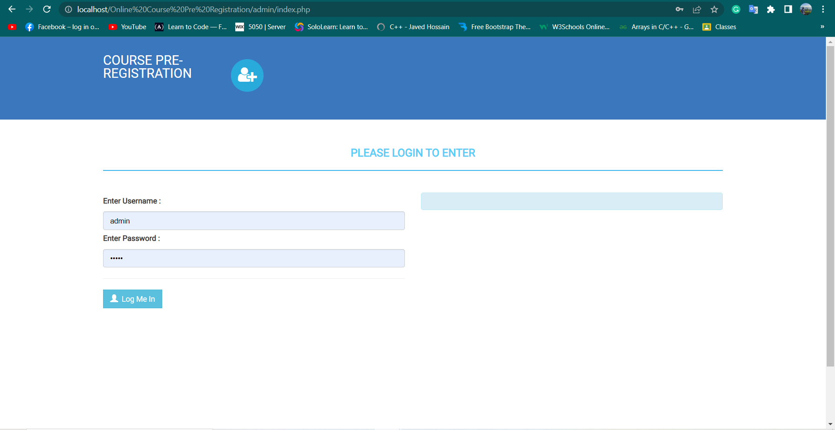

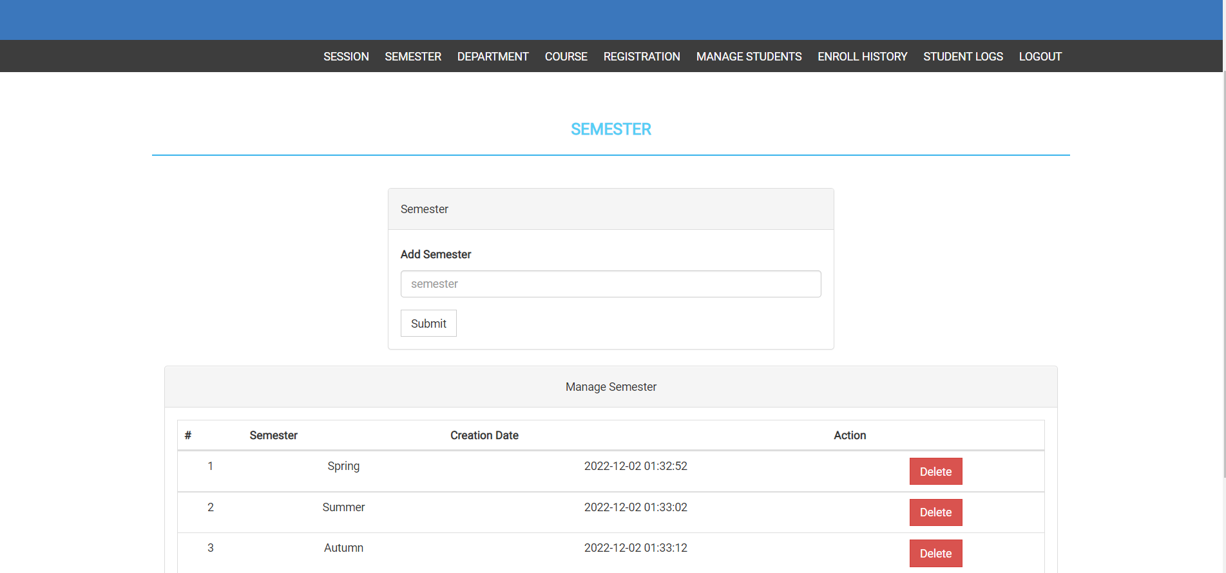

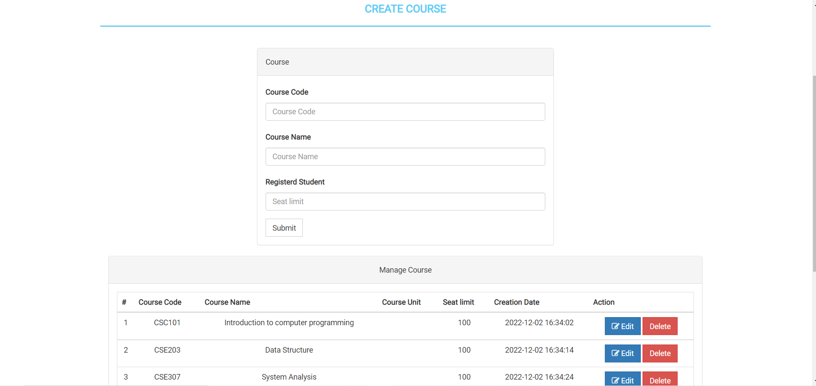

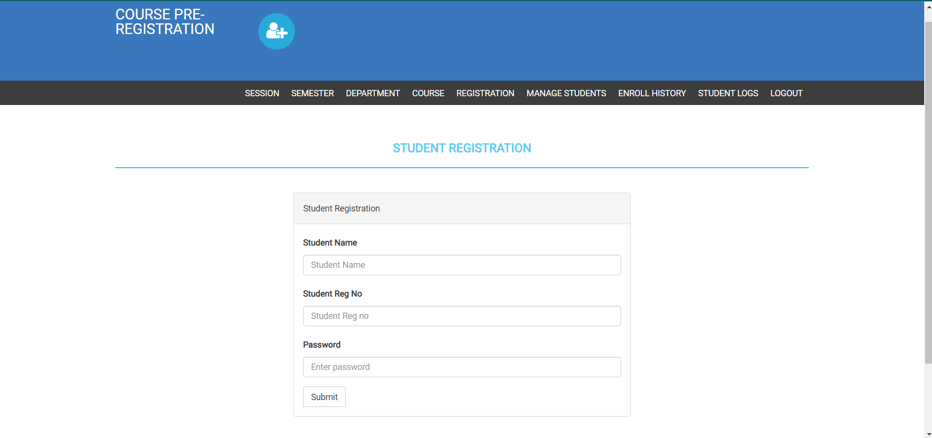

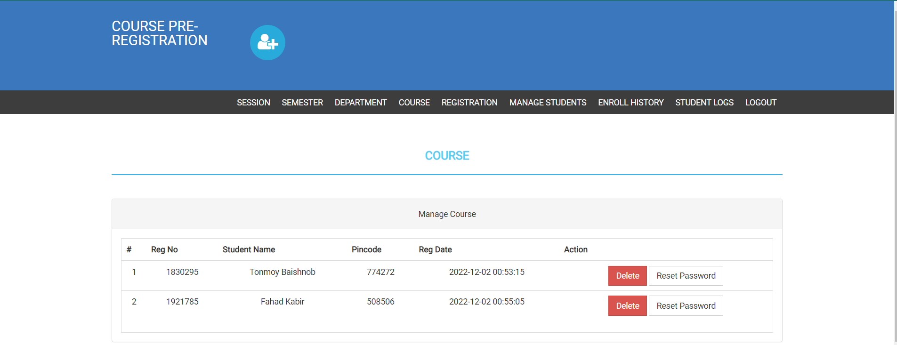

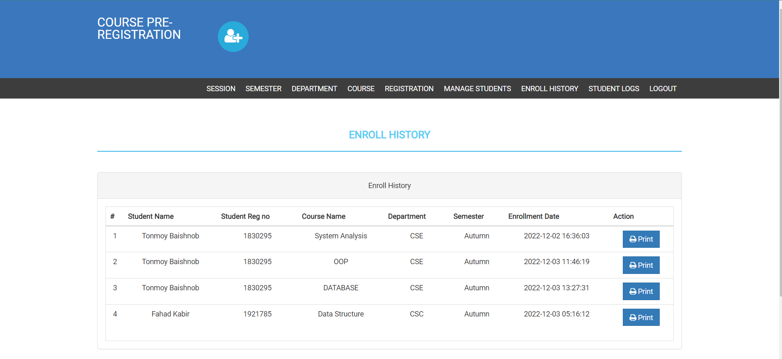

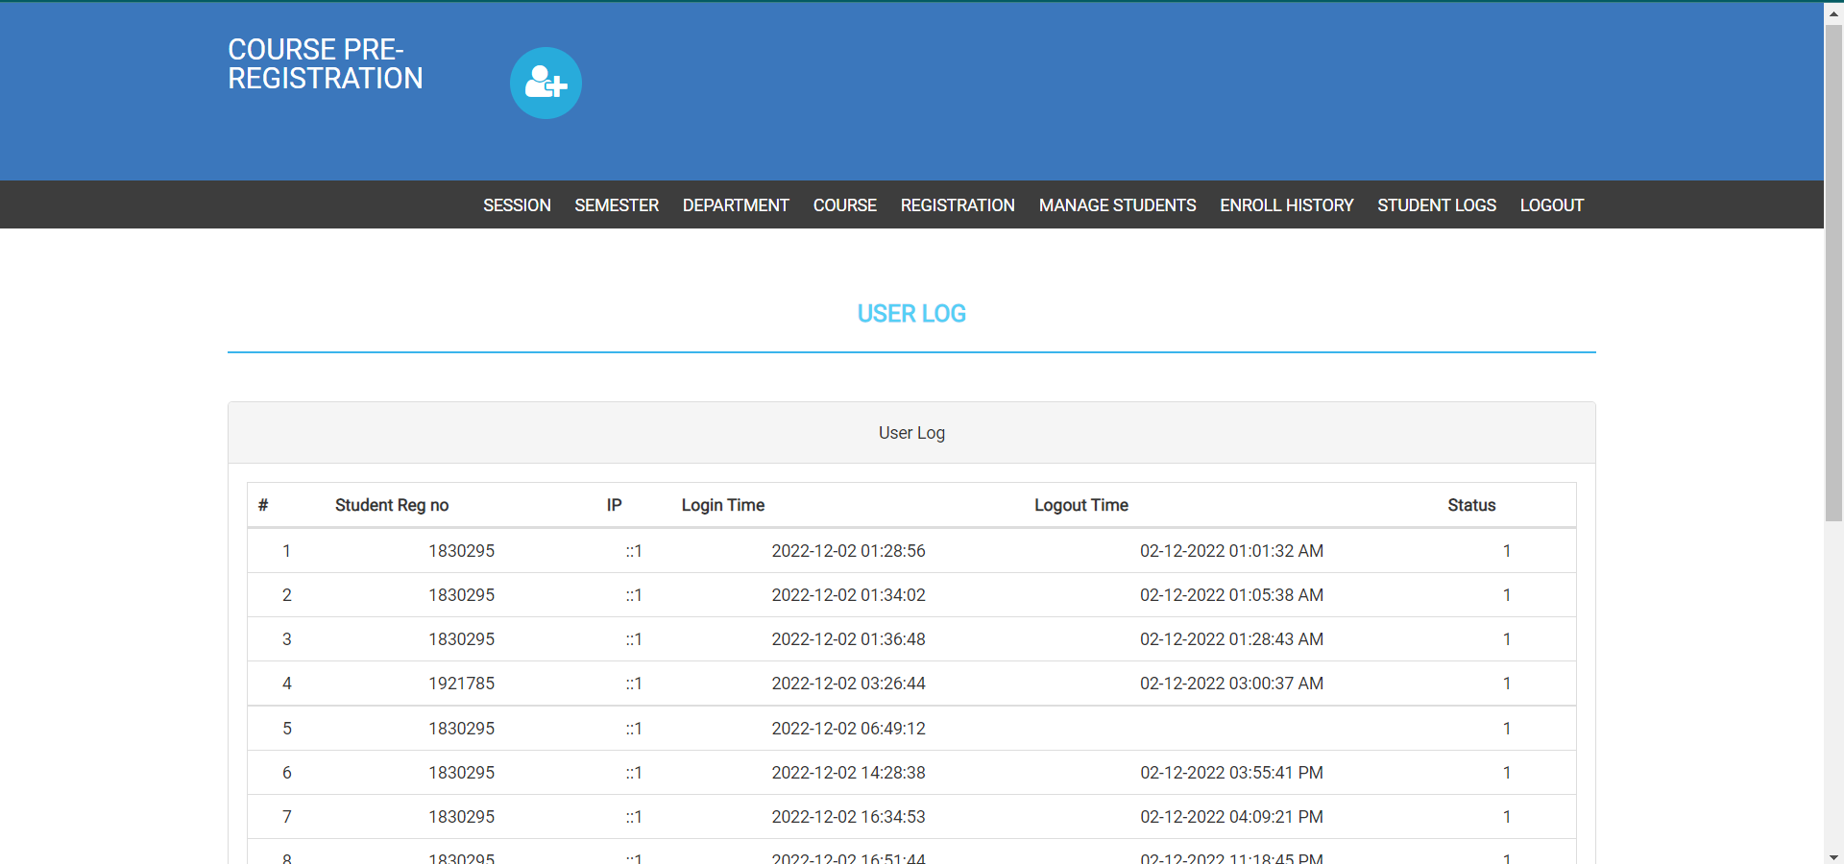

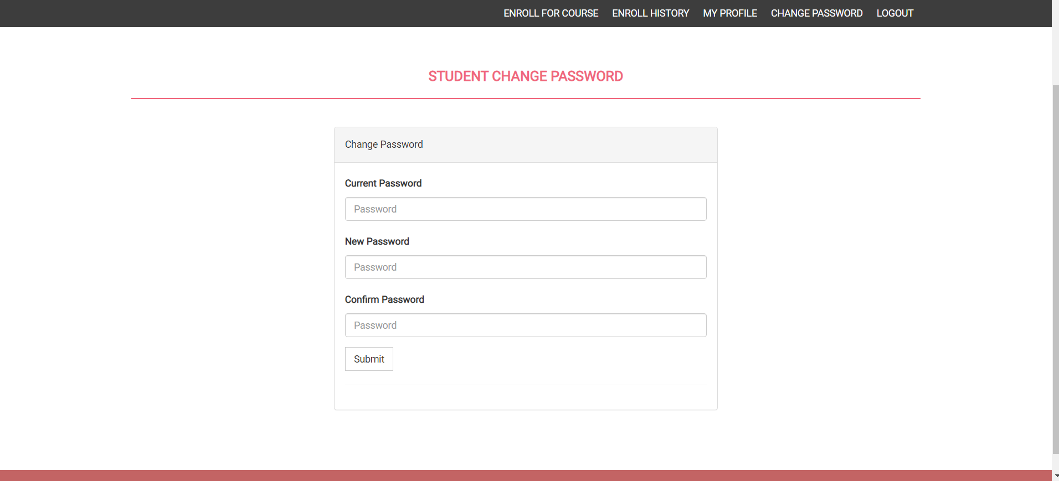

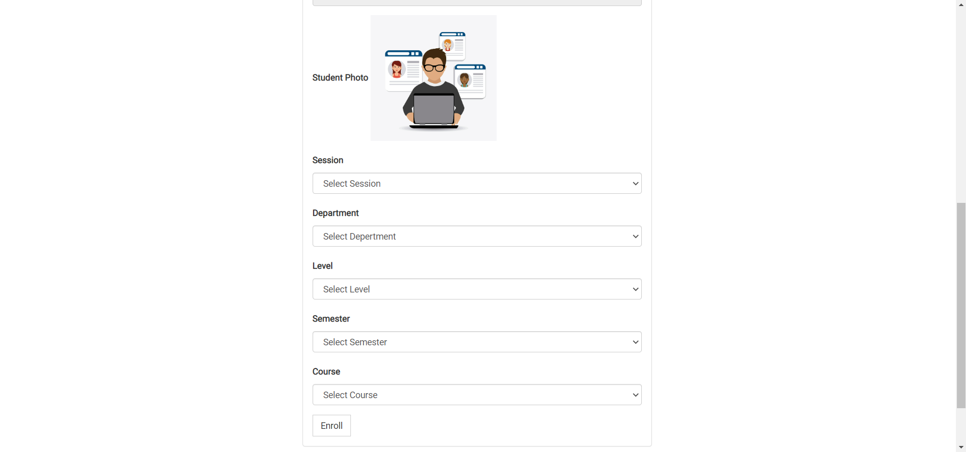

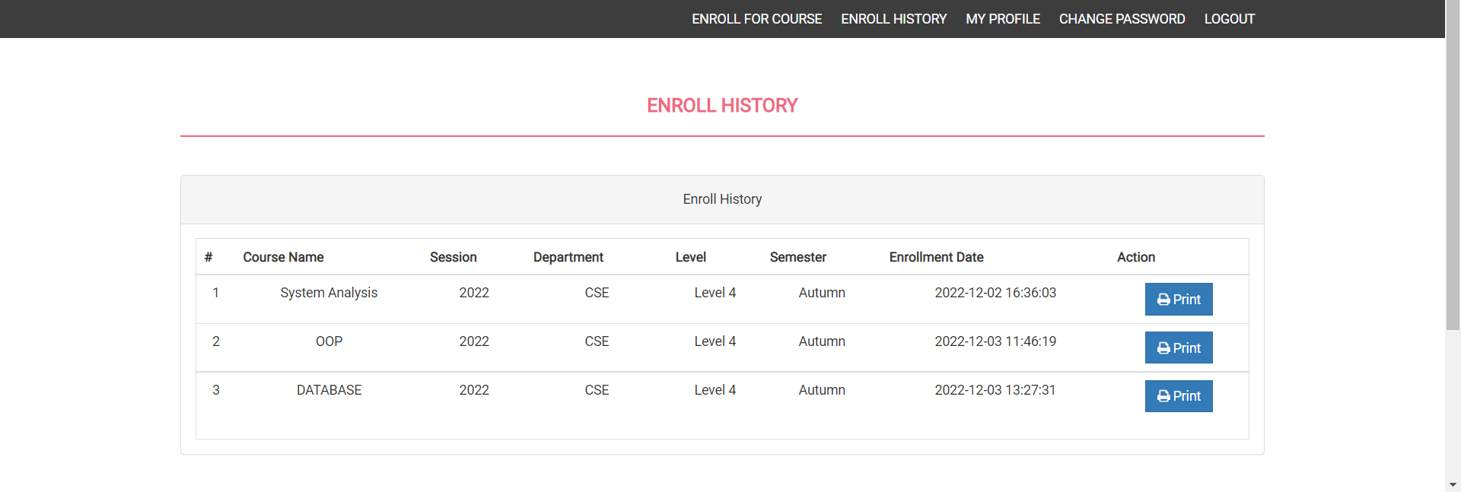

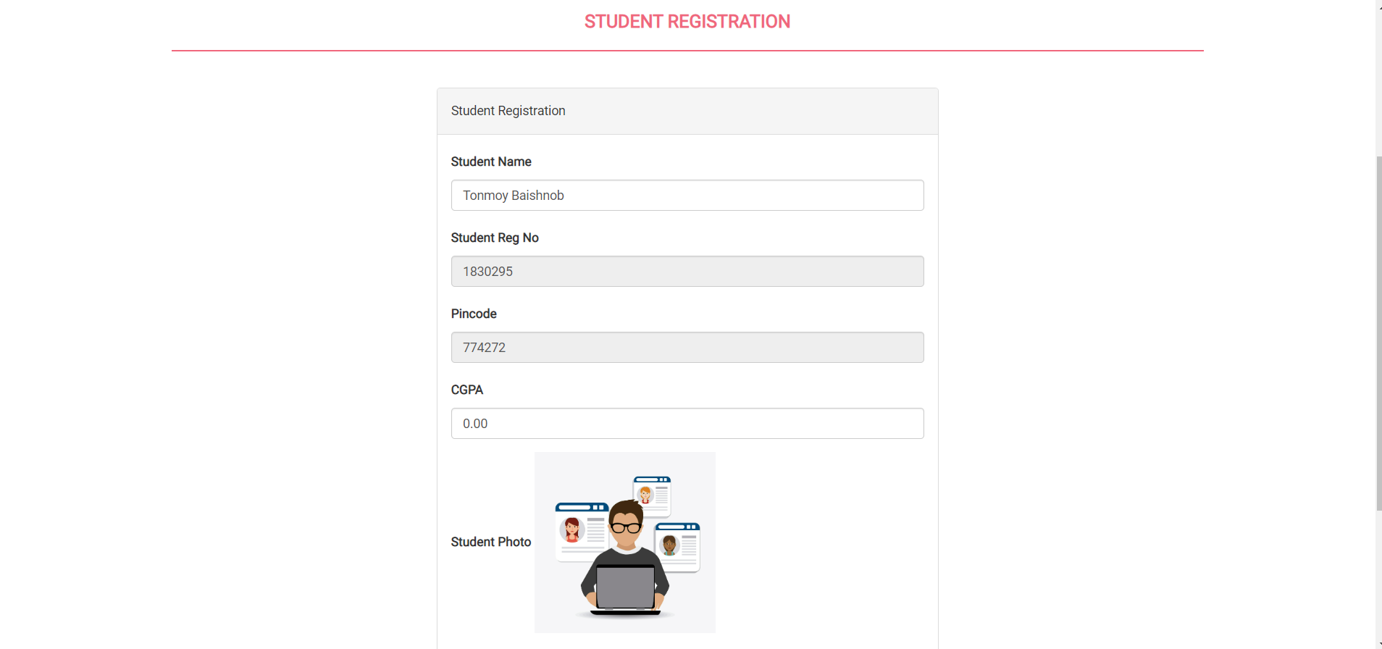

***__________T_____H_____E_______E______N________D__________***